**API Services** AI Technologies

**Google Map API**

The application that I would like to propose is this Google Maps API. This application is to help the user to easily guide themself while using the application anywhere and everywhere. It involves 2 API services, landmark detection, and text detection.

The Google Map API gives users the privilege of nearly limitless geographic aptitude at their fingertips. Search nearby restaurants, niche shops, and whatever else is in relative distance to your location.

One may have been using this API example more often than you realize. Each time one glimpsed business hours, reviews, contact information, or anything of that nature from that handy box on your screen, that is the Google Maps API in action.

To that same effect, clicking on the map icon in that box will open the Google Maps app for you or take you straight to the Google Maps website.

With this application, the user could be able to just take a picture and the Google Map API will tell them where they are, what is the place and what are the shops or restaurants nearer to the area. In addition, the user would also be able to know which exact area they are in right now just to take a picture of his/her street name.

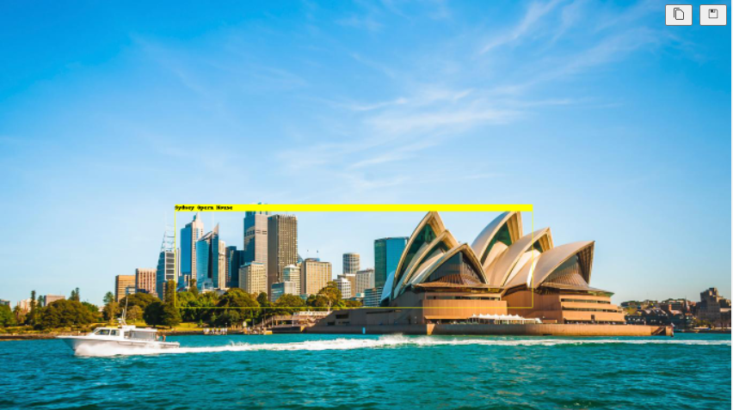

For example, in this place, when the user took a picture of the place, the google map API will tell them what place is this by using landmark detection.

Using text detection, Google Map API is able to detect the street road signboard.

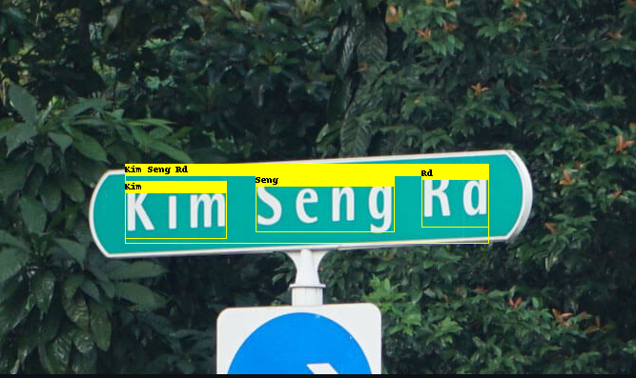

Well, there are other API services which Google Map API can do as well. Whether searching for the perfect restaurant, checking out the best hotels or finding the nearest bank, millions of people around the world get Google Maps to do the hard work for them.

Some examples of the website which uses Google Map API for their businesses.

**360 Cities**

360Cities is a global project which showcases beautiful panoramic, fully immersive images taken by some of the world’s leading virtual reality (VR) photographers. The Google Maps and Earth APIs give contributors a vital tool for adding new content while also providing an intuitive way for users to browse the available images. Since launching last year, 360Cities has grown rapidly to cover locations all around the globe and now has thousands of high-quality panoramas of some of the most interesting places on earth.

“Users’ experience of 360Cities is greatly enhanced with the geographical features offered by the Google Maps and Earth APIs. These are an integral part of our application and have been critical to our fast growth over the past year.”

**Challenges:**

* Data protection concerns.
* [Sometimes shows inaccurate location](https://www.trustradius.com/reviews/google-maps-api-2021-11-23-20-10-49).
* [It should be updated more frequently as the route/road changes from time to time](https://www.trustradius.com/reviews/google-maps-api-2021-12-03-03-27-31).

**Limited Accuracy**

Information in Google Maps may have [errors](http://www.cio.com/article/2405903/internet/6-memorable-google-maps-mishaps.html). Occasionally, ambiguities and flaws in location data may produce a route that doesn't take you to the destination you expect. Google Maps does not have up-to-the-minute information on unusual conditions, such as roads damaged by weather, blocked by street fairs or altered by recent construction work. Some remote locations may not be in Google Maps.

## Use by Criminals

The convenience afforded by Google Maps is not lost on thieves. Street View images can spot belongings momentarily exposed through windows or open doors. Burglars have used Street View and satellite images to find affluent neighbourhoods or homes that are easy to break into, or to identify parked cars that might contain expensive possessions.